~Weddings at the Cairngorm Hotel~

Cairngorm Hotel is the ideal Highland wedding venue. We pride ourselves on providing true Highland hospitality in a setting to match. Both religious and civil ceremonies can be held here at the hotel and our personal service and attention to detail make every wedding unique. Our team are more than happy to tailor your requirements to meet your needs for that special day.

Our function suite can comfortably accommodate 90 for dinner and up to 120 for your evening reception so whether you are looking for that big lavish day or something small and intimate, Cairngorm Hotel is perfect.

Our sample wedding menus offer a choice that will cater to every guest’s needs and our extensive wine list can provide the perfect glass of something to help proceedings go with a swing.

We have 31 rooms available with a complimentary double room for the happy couple (with breakfast). The imposing elegant hotel lends itself to beautiful wedding photography. Let us help you plan your very special day.

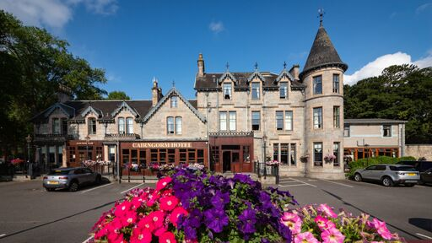

~www.cairngorm.com ~

~Wedding Ceremony & Terms~

The Cairngorm Hotel is pleased to offer the facility to hold your wedding ceremony, whether it’s a Civil or Religious service. There is a room hire charge of £200.00.
To secure your wedding date with us we ask for a £200.00 non-refundable deposit. We ask that 75% of your estimated bill is settled 28 days beforehand and the remaining balance is settled on the day of your departure.
Our newly refurbished Function Suite – with its own bar and toilet facilities - can seat up to 90 people for your Wedding Breakfast and 120 for the Evening Reception. For weddings for 40 guests or more, there is no Room Hire charge. Should your numbers drop below 40 Adult meals then a charge will be made for the hire of the room. All prices stated throughout are current as of August 2019 and may vary.
We will provide you with white table linen, red carpet welcome and menu printing. We also have white chair covers that are available for hire on request.

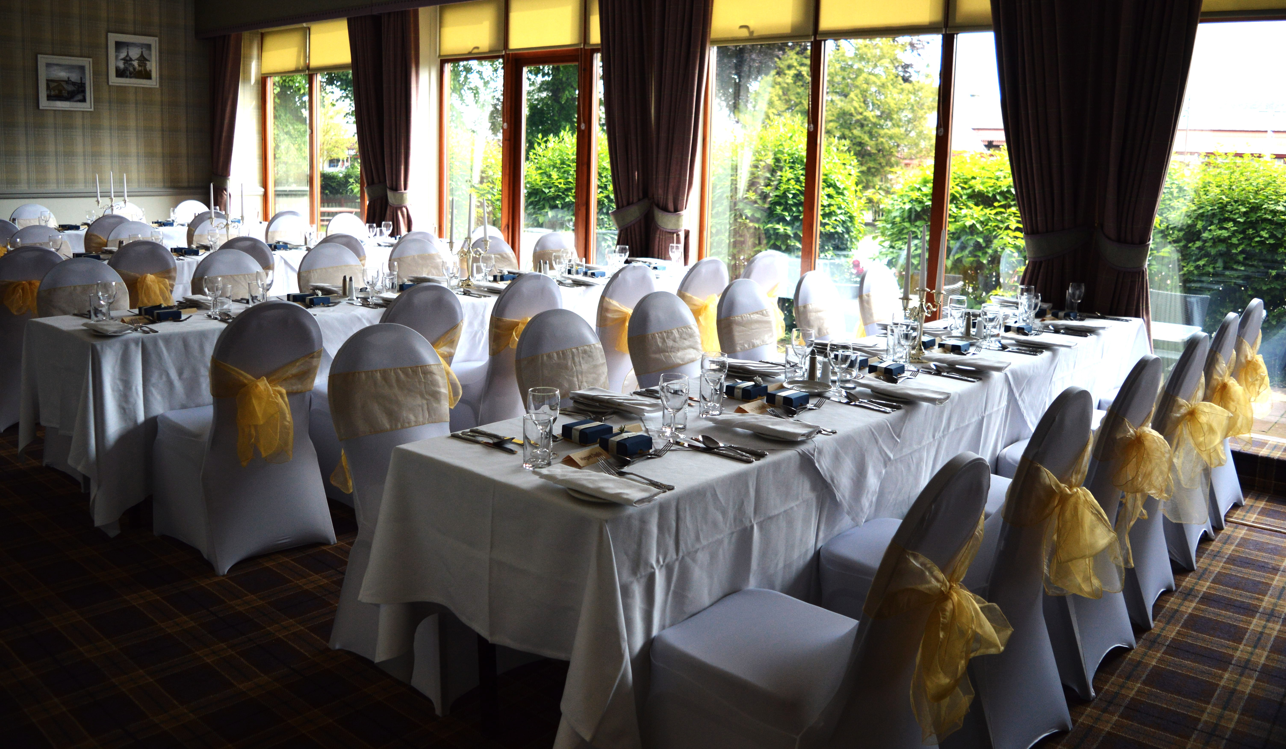

~ www.cairngorm.com ~

~Accommodation for Your Wedding Party~

We have 32 rooms at the Hotel all of which are en-suite. We are delighted to extend to your guests the discounted rates below. The discount will apply for up to 14 rooms (subject to availability) and is at the discretion of the hotel as to availability and the price charged. To avoid disappointment, it is recommended that you discuss room availability at the time of booking your wedding reception. Your guests will be asked for a £20.00 per room non-refundable deposit at time of booking. Our cancellation policy is 48 hours prior to 3pm on the day of arrival: otherwise the full amount will be charged. Any rooms that are blocked off for your party that remain unconfirmed without a name or deposit will be released automatically 8 weeks prior to the date of arrival.
Accommodation prices are based on a Bed &Full Highland Breakfast Package.
Single Rooms
The Hotel has 8 single rooms the rate is £70.00
Twin/Double Rooms
We have 14 rooms that can be made up as twin or double rooms and the rate is £50.00 per person based on two people sharing.
Double Rooms
We have 5 double rooms at a rate of £50.00 per person based on two people sharing.
Triple Room
We have one triple room which can be made up as 3 singles or a double & a single the rate is £135.00 for the room.
Family Rooms
We have two family rooms that can accommodate two adults and up to two children, the rate is £135.00
Double rooms for single occupancy will be £80.00
Here at Cairngorm Hotel we are pleased to offer you a complimentary room as bride and groom on the night of your wedding. Our normal check in time is 3pm and check out time is 11am on day of departure. Every effort will be made to accommodate any early arrivals, but unfortunately cannot be guaranteed. Please state at time of booking.
~ www.cairngorm.com ~

~ Sample Menu 1 £27.00~

Scotch Broth
Served with Crusty Bread
Smoked Haddock Fish Cake
Served with a Salad and Lemon Mayonnaise
Highland Haggis
Served with Mashed Tatties, Neeps and Gravy
XOXOX
Grilled Fillet of Salmon
With a Lemon & Parsley Butter
Breast of Chicken
Stuffed with Black Pudding and coated in a Creamy Peppercorn Sauce
Roast Sirloin of Beef
Served with Yorkshire Pudding in its own Pan Gravy
Spinach and Ricotta Filo Parcels
Accompanied by tomato sauce and served with linguine. Finished with Italian cheese
All served with New Boiled Potatoes and a Selection of Vegetables
XOXOX
Cranachan
Served with Shortbread
Sticky Toffee Pudding
Served with Butterscotch Sauce & Whipped Cream
Selection of Dairy Ices
XOXOX
Freshly Brewed Tea or Coffee

~ www.cairngorm.com ~

~ Sample Menu 2 £29.50~

Scotch Broth
Served with Crusty Bread
Smoked Salmon & Prawn Parcel
On a Dressed Salad with a Marie Rose Sauce
Flatcap Mushroom
Drizzled with Olive Oil, Tomato Concasse and glazed with Mozzarella and Cheddar
Chicken Liver Pate
With Beetroot & Apple Chutney and Cocktail Oatcakes
XOXOX
Baked Rolled Lemon Sole
With a Dill Cream
Breast of Chicken
With a Mushroom Cream Sauce
Roast Sirloin of Beef
Served in a Highland Sauce of Tarragon, Red Wine and Tomato
Vegetarian Shepherd’s Pie
Our take on this comforting classic contains Mushrooms, Onions, Carrots, Garlic and chickpeas bound in a Tomato sauce, seasoned with herbs and topped with Potato and Sweet Potato Mash
All served with New Boiled Potatoes and a Selection of Vegetables
XOXOX
Warm Apple Pie
Served with Whipped Cream
Selection of Dairy Ices
Selection of Scottish Cheeses
XOXOX
Freshly Brewed Tea or Coffee
~ www.cairngorm.com ~
~ Sample Menu 3 £31.50~

Scotch Broth
Served with Crusty Bread
Herb Crusted Goats Cheese
Served with Beetroot and Apple Chutney, on a bed of Crisp Salad Leaves
Pan Fried Scallops & Black Pudding
Served on a Potato Scone with a Balsamic Dressing
Smoked Duck Breast
Served with a Cranberry and Spiced Pecan Nut Salad
XOXOX
Grilled Fillet of Salmon & Langoustine
Served with a Lemon Butter
Breast of Chicken
Stuffed with Haggis in a Creamy Peppercorn Sauce
Haunch of Venison
Served with a Red Wine and Juniper Jus
Vegetarian Shepherd’s Pie
Our take on this comforting classic contains Mushrooms, Onions, Carrots, Garlic and chickpeas bound in a Tomato sauce, seasoned with herbs and topped with Potato and Sweet Potato Mash
All served with New Boiled Potatoes and a Selection of Vegetables
XOXOX
Trio of Mini Desserts
Sticky Toffee Pudding with Butterscotch Sauce
Cranachan
Dark Chocolate Cheesecake
XOXOX
Selection of Scottish Cheese Nibbles
XOXOX
Freshly Brewed Tea or Coffee & Orkney Fudge
~ www.cairngorm.com ~

~Arrival/Toast Drinks~

Large Jug of Fresh Orange……………from £6.00 per Jug
House Red and White Wine………...from £17.50 per bottle
Prosecco……………...from £23.95 per bottle
Champagne…………………………..from £44.00 per bottle
Extensive Wine List also available.
We do not permit refreshments to be provided by any party other than the Hotel unless by prior arrangement with the management where a corkage charge will apply.

~Evening Buffets~

Option 1 £4.95
Highland Stovies Served with Oatcakes
Option 2 £4.95
Chilli and Rice
Option 3 £4.95
A Selection of Sandwiches, Tea, Coffee and Shortbread
Option 4 £7.95
Haggis Balls
Mini Quiche
Assorted Sandwiches
Chicken Dips
Assorted Vol au Vents
Home-made Sausage Rolls
Bite Sized Nibbles
Tea/ Coffee & Shortbread
~ www.cairngorm.com ~

~Cairngorm Wine List~
White Wine Selection

175 ml Glass 250 ml Glass Bottle
- CyT Chardonnay £4.70 £6.10 £17.95
Delicious Chardonnay with soft fruit aromas and flavours followed by a fresh, fruit filled finish (Chile) (3)

- CyT Sauvignon Blanc £4.70 £6.10 £17.95
Fruity and dry with melon and citrus fruits on the nose and zingy gooseberry flavours on the palate, followed by a slight vanilla undertone and a long finish (Chile) (2)

- La Casada Pinot Grigio £5.30 £6.95 £19.95
Crisp and refreshing with wonderfully soft apple fruit flavours followed by a clean, fresh finish (Italy) (2)

- Franschoek Cellar Chenin Blanc £5.40 £7.60 £22.35
A full and rich Chenin Blanc with expressive fruit aromas, concentrated tropical fruit flavours and a rich, creamy finish. Zingily fresh and delicious. (South Africa) (4)

- Boundary Hut Sauvignon Blanc £21.45
A nose full of ripe capsicums, gooseberries and lime followed by flinty notes of tomato leaf. A round but crisp palate with a nice back bone of acidity. (New Zealand) (1)

- Gerard Tremblay Chablis £37.00
Gerard Tremblay produces the most elegant style of Chablis – very mineral, clean and unspoiled by excessive oak. An old fashioned and worthy style. Good honeyed fruit on the nose with crisp, steely fruit on the palate, giving a wine of great finesse (France) (2)

- Le Versant Voigner £22.45
Beautiful yellow colour with green glints. Intense nose of apricots, ripe peach and exotic fruits. The palate has a fresh, crisp acidity and a long, lingering finish (France) (2)

Rose Wine Selection

- La Casada Pinot Grigio Rose £4.95 £6.20 £18.45
An oddity of the wine world that is wonderfully refreshing, with crisp acidity backed up by pleasant, soft red fruit flavours. (Italy) (2)

- Zinnia Zinfandel Rose £4.95 £6.20 £18.45
A soft, fruity rose with fresh red berry aromas and flavours followed by a lingering. Refreshing finish (USA) (4)

Taste Guide
White Wines – 1 to 9 Driest to Sweetest
Red Wined – (a) to (e) Light to Full bodied

125 ml Glass also available

~ www.cairngorm.com ~
Red Wine Selection

175 ml Glass 250 ml Glass Bottle
- CyT Cabernet Sauvignon £4.70 £6.10 £17.95
A soft, attractive red with blackberry and plum fruit flavours followed by a subtle touch of spice (Chile) (b)

- CyT Merlot £4.70 £6.10 £17.95
Deep ruby in colour with a cherry wood and plum nose. The palate shows bags of
jammy fruit and smooth tannins (Chile) (b)

- Coorong Estate Shiraz £5.30 £6.95 £19.95
Well-rounded, ripe black fruit aromas and flavours with a peppery, spicy edge and
rich tannins (Australia) (c)

- La Poderosa Malbec £5.45 £7.00 £20.45
An intense red-violet colour with aromas that reveal cherry and plum underscored
by a delicate touch of vanilla (Chile) (c)

- Le Versant Pinot Noir £22.95
A strong and aromatic nose of red fruits mixed with liquorice notes. The palate is
full bodied with round tannins (France) (2)

- Chateau de Fleurie £29.50
One of the great individual Crus or special villages wines, here bottled by the owner. This is a
plump, fresh, elegant juicy wine of much fruit and mouth-watering appeal which really tingles on
the palate. (France)

- Bodegas Beronia Rioja Crianza £24.95
Garnet in colour with strawberry and blackberry aromas. Smooth and silky on the palate with fresh cherry fruit, chocolate and coffee flavours. (Spain) (c)

Sparkling Wine & Champagne

- Vigna Dogarina Prosecco Brut N.V. 200 ml bottle £7.50 £23.95
Pale yellow in colour with persistant perlage. Citrus fruit and flowery features characterise the
wine’s scent. Fresh and distinctive, exhaled in the aromatic notes (Italy)

- Vigna Dogarina Spumante Rose N.V. 200 ml bottle £7.50
Pink with lively and persistent perlage. Fresh and fruity. Delicate and harmonious. (Italy)

- Maillart Champagne Brut N.V. £44.00
Golden in colour with intense aromas of fruit and toasty hazelnuts. Wonderfully
fresh and fruity with great finesse ( France)

- Moet et Chandon Brut N.V. £59.00
Fresh and fruity with a good, persistant mousse and a well balanced palate (France)

All prices include VAT at the standard rate
When one vintage ceases to be available then the next suitable one will be offered
All our wines have an alcohol content of between 7 & 15% unless otherwise stated
~ www.cairngorm.com ~

~Useful Contacts~
Photographers
Aviemore Photographic | 01540 651322 | www.aviemorephotographic.com
Cairngorm Photography | 07786866935 | www.cairngormphotography.com
Chris Scott Photography | 01382 767667 | www.chrisscottphotography.co.uk
Car Hire
Aviemore Taxis | 01479 811 111 | www.taxisinaviemore.co.uk
Bremners Buses | 01479 812 322 | www.bremnersaviemore.co.uk
Florists
The Flower Company | 01463 232554 | www.flowersinverness@gmail.com
Unique Floral Designs by Elaine | 07742 058 049 | www.grantownflowers.co.uk
Piper
Calum Fraser (Spud) | 01479 810 033  07793 491367 | www.spudthepiper.co.uk
Jemma Docherty | 07956072342
Event Decor  AyeDoEvents  Chair covers & event decor | 07776144604 | ayedoevents@btinternet.com
Beauty
Snippitz | 01479 811 855 | www.facebook.com/snippitz.aviemore
Beautique | 01479 810 711 | www.beautiqueaviemore.co.uk
Ampla Vella Hair & Beauty | 01540 662003
Entertainers

Anne Dickson Band | 01479 841 312 | band@annedicksonband.co.uk
Encore Musician Booking |  | jonny@joinencore.com
Diamond Skies | 07707 651565
Chris Grant | 07969 338282
Registrars
Highland Council Registrar | 01463 256400 | www.highland.gov.uk
Aviemore | 01479 813146/7
Lesley Simpson  (Humanist Society) | 01479 872772 | www.humanism.scot/ceremonies/find/5/lesley-simpson/
Churches/Chapels
St Andrew’s | 01479 810280
Alvie | 01479 810280 | www.alvieandinshchurch.org.uk
Insh | 01479 810280 | www.alvieandinshchurch.org.uk
St Aiden’s | 01479 810229
Cake Companies
Jasmine & Rose | 01540 673 817 | www.jasmineandrosecakecompany.co.uk
Ildiko Cakes | 07414228122 | www.ildikocakes.com

01479 810 233
~ www.cairngorm.com ~

